

|  |  |  |  |  |  |  |  |  |
| --- | --- | --- | --- | --- | --- | --- | --- | --- |
|  | | | | | | | | |
|  | | Deep Learning by PyTorch | | | | |  | |
|  |  | | | | | | |  |
|  | | | |  |  | | | |
|  | | | | Utsav Anantbhat |  | | | |
|  | | | | 1/31/2023 |  | | | |
|  | | |  | | |  | | |

Final Network Table:

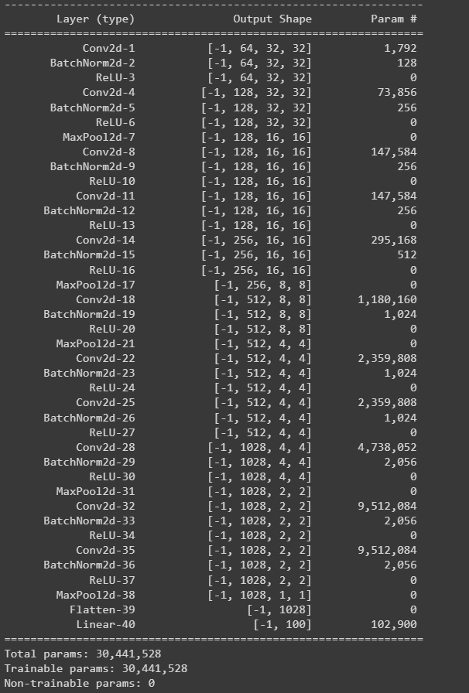

The above table shows the layers, output shape, and number of parameters for each layer.

Colab Notebook Plot:

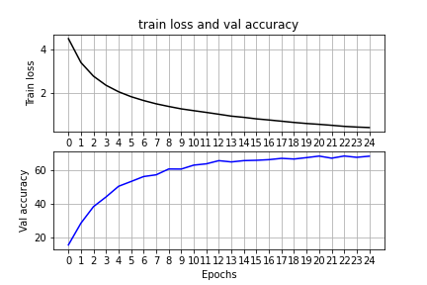

We ran the model for 25 epochs. We observed that these many would be enough to train the model.

Ablation study:

|  |  |  |
| --- | --- | --- |
| **#** | **Model architecture** | **Best accuracy on val set** |
| 1 | BaseNet | 21% |
| 2 | BaseNet + Data augmentation | 30% |
| 3 | BaseNet + Data augmentation + Data normalization | 50% |
| 4 | Deeper Network + Data augmentation + Data normalization | 68.7% |
| 5 | Deeper Network + Data augmentation + Data normalization + Batch Normalization | 69.2% |

Base performance/Relative performance:



Part 2:

Pre-tuning:

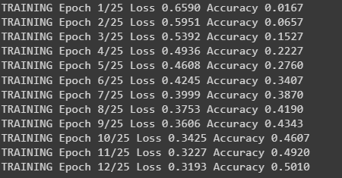

Post-tuning:

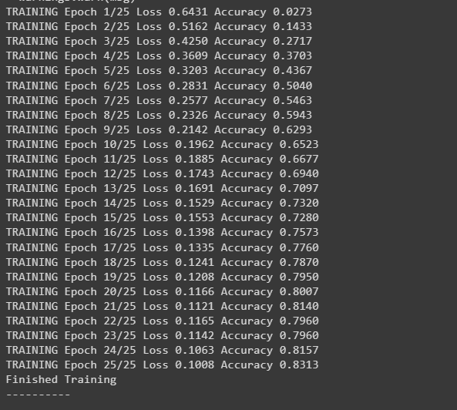

Test accuracy:

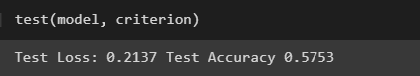

Parameters used:

